Sunday | Monday | Tuesday | Wednesday | Thursday | Friday | Saturday
Long Branch  Baptist Church  JUly 2018 |  |  |  |  |  | 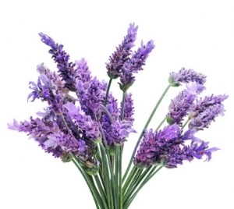
1  No S. School;  10:30am Worship  Happy Canada Day! | 2  9:30-12:00pm  VBS | 3  9:30-12:00pm VBS  7pm Prayer | 4  9:30-12:00pm VBS | 5  9:30-12:00pm VBS;  7:00pm Parents Night | 6  9:30-12:00pm VBS;  Clothing Outlet is Closed | 7
8  10:30 am Worship/ Caring Fund/Food Drive, Lord’s Table | 9 | 10  7 pm Prayer | 11 | 12  10 am Prayer in Pastor’s office | 13 9:30am-11am Clothing Outlet;  2pm Elders;  5:30pm Mandarin Group | 14
15  10:30 am Worship | 16 | 17  7 pm Prayer | 18 | 19  10 am Prayer in Pastor’s office | 20  9:30am-11am Clothing Outlet | 21
22  10:30 am Worship | 23 | 24  7 pm Prayer | 25 | 26  10 am Prayer in Pastor’s office | 27  9:30am-11am Clothing Outlet; 5:30pm Mandarin Group | 28
29  10:30 am Worship/ Lord’s Table | 30 | 31  7 pm Prayer
Contact Us: 416-251-1525, admin@longbranchbc.ca.

