Sunday, May 4, 2014
Call to Worship #39 Doxology

How Great is Our God
#54 Great is Thy Faithfulness

Opening Prayer
Special Music: Statement of Faith

Welcome & Announcements
# 8 To God Be the Glory
Special Music: I am Not Ashamed of the Gospel

Congregation Memories
Interview with Andrew Gordon

Scripture: 2 Corinthians 9: 6-15 (Pew Bible pg. 1163)

Praying for Others
Regular Offering
How Good It Is
Children up to Grade 5 may leave for Junior Church
Congregation Memories
Special Music: He’s Always Been Faithful

Message by Andrew Gordon “Moments that Matter”
By Faith
Closing Prayer & Postlude

------------------------------------------------------------------------------
LONG BRANCH THIS WEEK
Today: 10:00am 100th Anniversary Service
Light Luncheon
Tuesday: 7:00pm Prayer Meeting
Thursday: 10:00am Prayer with Pastor Rob
7:30pm Archer’s Encouragement Group
Friday: 9:30am-11am Clothing Outlet
7:00pm Root Down
Saturday: 2pm-4:30pm Eleanor Birthday OPEN HOUSE
7:00pm Young Adults Bible Study
Next Sunday: 9:45 am Sunday School
11:00 am Worship/Lord’s Table,
Caring Fund, Food Drive

TODAY’S SERVING SCHEDULE

Ushers
May: Peter Grightmire, Alyssa Pan, Stanislav Shevchenko

Nursery
Today: Brent & Colleen Saunders, Anhelika S; Iain
Davis & Boot Saguisag, Luke W; Joyce
Annable, Steve Smith, Jessica Lambie;
May 11: Alyssa Pan, Christie, Anhelika S
Junior Church
Today: Shona Wright, Nathan Wright
May 11: John Wright, Luke Wright
Tellers
Today: Nancy Mawhinney
May 11: Nancy Mawhinney
Building Security
Today: Ben Chan
May 11: Stan Tait
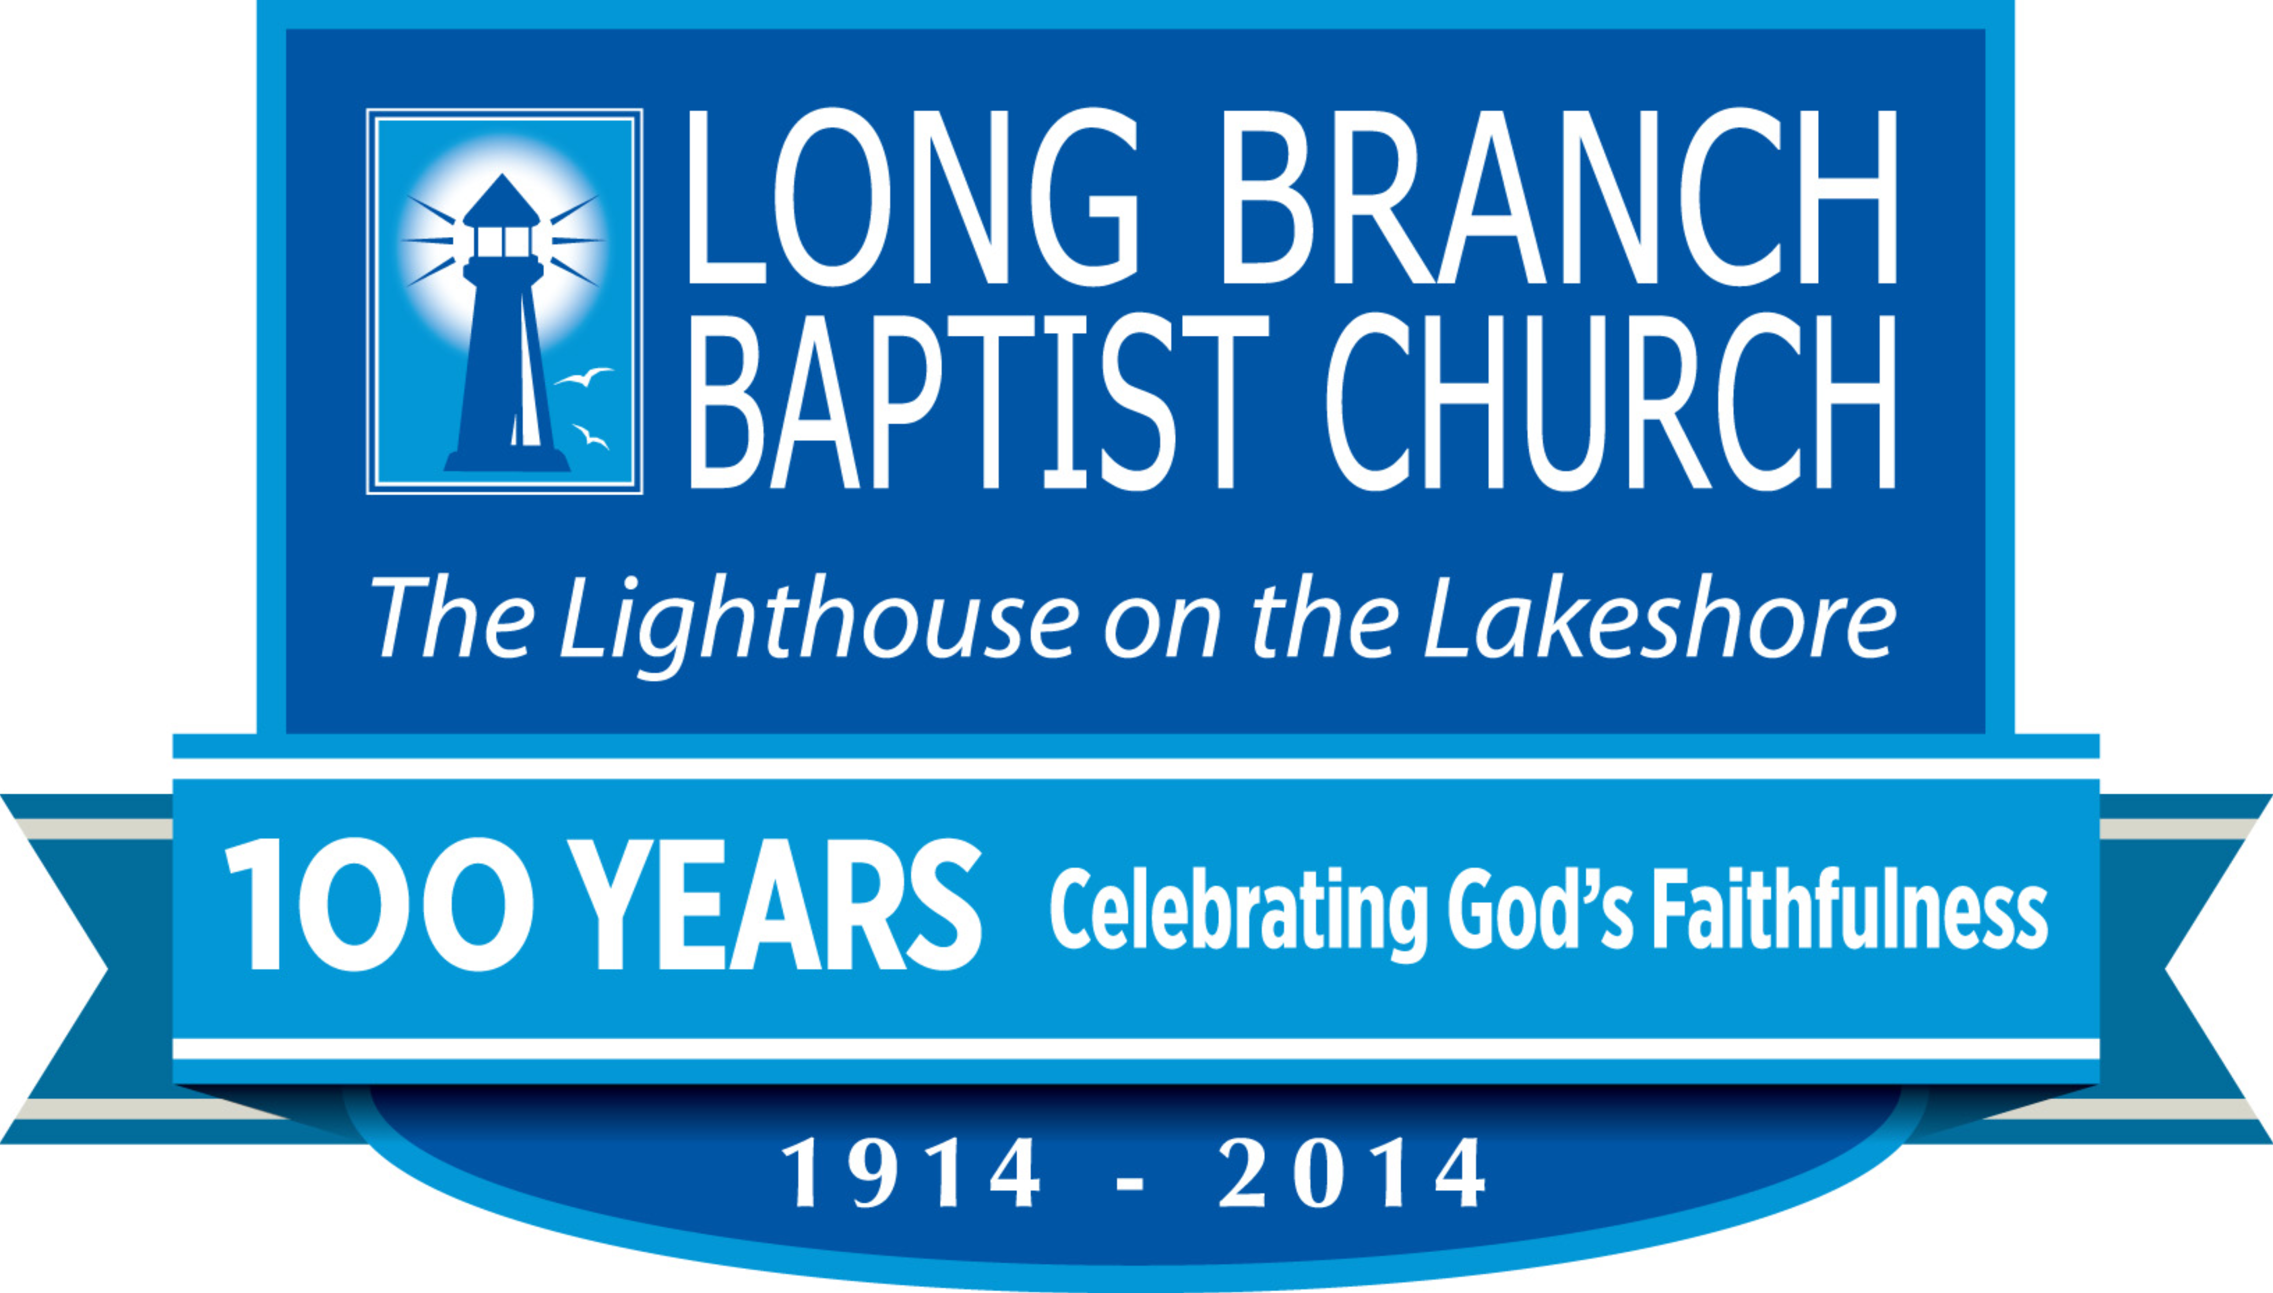
We approved a plan to form a teenage girl’s group. Tom King’s name showed up in the 1948 minutes regarding a Young Peoples Report. Central Baptist Seminary received our support. Plans for a new church were approved.

Gord Culbert new address:
The Westbury Long Term Care, Room 820
495 The West Mall, Etobicoke, ON M9C 5S3

Reminder
The family of Eleanor MacFarlane is celebrating her 80th year with an OPEN HOUSE this Saturday May 10, 2014 at Long Branch Baptist Church from 2pm-4: 30pm. Best wishes only, please! All are welcome!

Thank You
Daniel Muller thanks us for our generous offering on Good Friday for the ministry of New Covenant Forum. The combined offering from our two churches was $1699.05
ANNOUNCEMENTS
Welcome
Andrew Gordon will be sharing with us from God’s Word today. Andrew served on staff at Long Branch from 1991-1995 as youth pastor while he was a student at Ontario Theological Seminary. He met his wife Amy (Russell) here at LBBC and they were married in June 1996. They have four sons: Johnathan 15, Matthew 13, Eric 11 & Mitchell 7. Andrew is the Lead Pastor at Chartwell Baptist Church in Mississauga, a church he and Amy helped plant in 1996. In 2012 Andrew faced a life threatening health challenge that both shook and solidified his faith.

100th Anniversary Offerings
Our theme this year is “100 years- Celebrating God’s Faithfulness.” God has been so good to us as a church and in today’s celebration, we want to gather a special offering (in addition to our regular offering) in order to bless our city and the nations with God’s love and grace. Our special offering goal is $15000 and it will be distributed in the following five ways; $3000 toward the ministries of Urban Promise in Toronto; $3000 toward Pastor Jose and Daglis’ new house church building in Los Tunas, Cuba. $3000 toward clean wells and water in Nigeria in connection with our Partners International missionary, David Umune; $3000 toward rescuing girls from the sex trade in Nepal in either direct or indirect connection with our Partners International missionary, Man Bahadur Tamrakar; $3000 toward Philippine Missionary Fellowship (under Partners International) as they minister to people following last year’s typhoon disaster in the south and central Philippines. Special Anniversary/ Missions offering envelopes are available in the pews. Please make sure that we have your name and address on the envelope (or your envelope number) so that you can receive a receipt at the end of the year. Thank-you, in advance, for your participation in these very worthy causes.
.
Thank You
I would like to thank all my friends at Long Branch for praying for me and supporting me in this trying time. My surgery was a success. My blood was just right and I could feel the Lord's presence the whole time. I know it was your prayers seeing me through this procedure. Carolyn Hynek

